COMP3210/6210: Report for Assignment 2

- Group Member Information
Name | Student ID | Email: | Assigned Task
Ismam Sayer | 48541133 | ismam.sayer@students.mq.edu.au | Task 2: NN Search using Best-First (BF)
- Program Execution Requirements

  - Program Environment (e.g., OS, database, CPU, etc.)
Task 2 (Best-First NN search):
Item | Details
Operating system | Windows (64-bit)
CPU / RAM | AMD Ryzen 7 7800X3D, 32 GB DDR5-6400
Language / version | Python 3.11.9 (virtual environment .venv)
IDE | PyCharm
Libraries | Only standard library modules allowed by the brief: sys, time, math, heapq. No R-tree library is used - the R-tree is our own shared module rtree.py.

  - Input Files and Parameters (directory settings and other parameters)
Task 2: all files are kept in one project folder. Task2.py and the shared rtree.py are in the same folder, so Task 2 imports the shared R-tree directly.
Assignment2/
├── rtree.py (shared R-tree module - group task)
├── Task2.py (Task 2: Sequential scan, BF, BF + D&C)
├── Task2_output_<dataset>.txt (created when the program runs)
└── datasets/
├── Sample_Data/NN_BF_search.txt
└── Task2_Datasets/
├── hospital.txt library.txt ev_charging_station.txt
└── query_points_BF.txt
Parameter | Where it is set | Value used
Dataset | DATASET at the top of Task2.py, or the 1st command-line argument | library (placeholder until the group dataset is known). Chosen by (sum of last digits of the 3 student IDs) mod 3: 0 = hospital, 1 = library, 2 = ev_charging_station
Max node capacity B | B at the top of Task2.py, or the 2nd command-line argument | B = 16 for the full dataset; B = 4 for the sample analysis
Min node fill | Worked out automatically in RTree | ⌈0.4 × B⌉ entries per node after a split (Week 8 rule)
D&C subspaces | parts in split_by_y | 4 (sorted by y, almost equal size)

Execution commands (run inside the Assignment2 folder, or press Run in PyCharm):
python Task2.py # uses DATASET and B set in the file
python Task2.py library 16 # choose dataset and B on the command line
python Task2.py sample # prints the step-by-step sample analysis (B = 4)

  - Additional Requirements
Task 2:
• The working directory must be the Assignment2 folder, because the dataset paths are relative (datasets/...).
• Only the search for the 200 queries is timed (time.perf_counter). Reading files, building the R-trees and writing the output file are outside the timer, as required.
• The output file Task2_output_<dataset>.txt holds all three methods: one line per query (Query 1: id=..., x=..., y=..., distance=...), the total and average running time of each method, and a summary.
Running results (library dataset, B = 16):
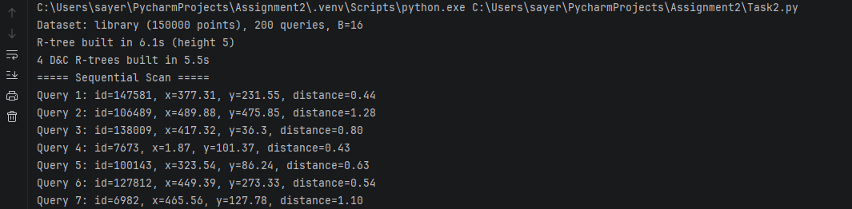
Screenshot 1 - Start of the run: dataset, B and R-tree build times (not part of the timed search)
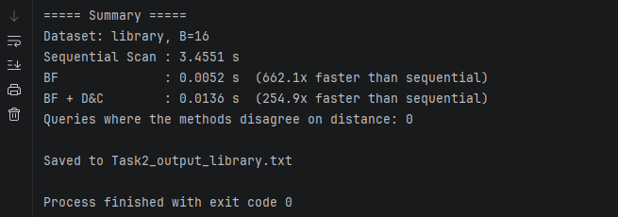
Screenshot 2 - Summary with the running time of each method
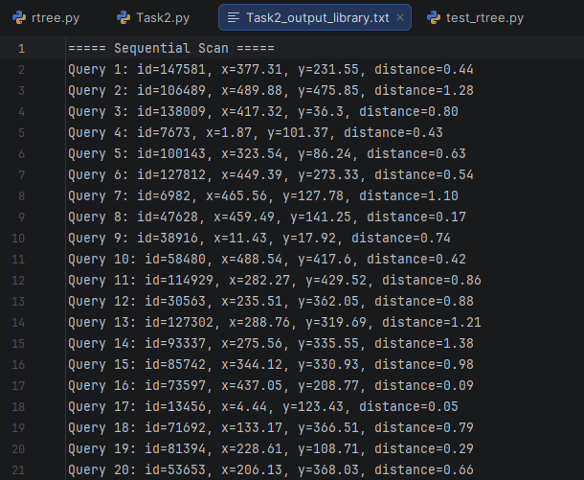
Screenshot 3 - Start of Task2_output_library.txt

- Program Documentation
3.1 TASK 1:

3.1.1 Program Organization
If your assignment consists of multiple files and/or classes, please provide brief, high-level descriptions of each file/class within your program, as illustrated below.
Class/File Name | Description (detailed information)
Function Description
Function Name  (parameters) | Description (detailed information)
    - Analyzing the Working of Task 1:

      - The Process of R-Tree Construction

      - The Process of BaB Algorithm

      - The Process of Divide-and-Conquer

3.2 TASK 2: Nearest Neighbour Search using Best-First (BF) - Ismam Sayer (48541133)

3.2.1 Program Organization
If your assignment consists of multiple files and/or classes, please provide brief, high-level descriptions of each file/class within your program, as illustrated below.
Class/File Name | Description (detailed information)
rtree.py (shared) | Group R-tree module used by all three tasks. Contains the Point, MBR, Node and RTree classes and the file loaders. Handles subtree selection (minimum perimeter increase), insertion, overflow, node splitting (best perimeter-sum split on x or y, each side ≥ 0.4B) and MBR / parent / root updates. Task 2 only uses it to build trees and read MBRs - no R-tree code is duplicated in Task2.py.
Task2.py | Individual Task 2. Implements the three NN methods (sequential scan, Best-First search, BF with divide-and-conquer), times the search for the 200 queries, checks that all three methods agree, prints the results and saves them to one .txt file. Also has a "sample" mode that prints every step of the worked example in Section 3.2.2.
datasets/Task2_Datasets/ | Input files: the three facility datasets (150,000 points each, format id x y) and the 200 query points.
Task2_output_<dataset>.txt | Output produced by Task2.py (results of all three methods + running times).
Function Description
Function Name  (parameters) | Description (detailed information)
distance(p, qx, qy) | Returns the Euclidean distance √((p.x − qx)² + (p.y − qy)²) between data point p and the query location. Used by all three methods so distances are calculated the same way everywhere.
sequential_scan(points, q) | Method 1. Loops over every point in the dataset, works out its distance to query q and keeps the smallest. Starts with best distance = infinity. Returns (nearest point, distance). This is the baseline for correctness and running time (150,000 distance calculations per query).
best_first(tree, q, trace=False) | Method 2, follows the Week 9 BF pseudocode. Keeps a min-heap H of (mindist, counter, node) so the entry with the smallest mindist to q is always removed first. Starts by putting the root in H. While the distance of the current best point p_best is greater than the smallest mindist in H: remove the top entry; if it is an internal node, push all its children with their mindist (MBR.min_dist); if it is a leaf, compute the distance to every point in it and update p_best. It stops as soon as no entry in H can contain a closer point, so the rest of the tree is never accessed. The counter only breaks ties so two nodes are never compared directly. With trace=True it prints H and p_best after every step (used for Section 3.2.2). Returns (nearest point, distance).
heap_text(H) | Helper for the trace output. Returns H as text sorted by mindist, e.g. {(N4, 0.00), (N2, 2.00)}. It sorts a copy, so the real heap is not changed.
split_by_y(points, parts=4) | First step of Method 3. Sorts the points in ascending order of y (x breaks ties) and cuts the sorted list into parts groups of almost equal size (sizes differ by at most 1; extra points go to the first groups). Returns a list of 4 point lists.
build_dc_trees(points, B, parts=4, verbose=False) | Builds one separate R-tree for each subspace from split_by_y, using the shared RTree class with the same B and the same construction rules. With verbose=True it prints which points went into each subspace and every insertion step.
best_first_dc(trees, q, trace=False) | Method 3. Runs best_first independently on each of the four subspace R-trees to get one candidate NN from each, then compares the four candidate distances and returns the closest as the final NN of the whole dataset.
run_method(name, search, queries) | Runs one search function on all 200 query points. Starts the timer just before the loop and stops it right after, so only the search is timed. After the timer stops it formats one line per query (query id, NN id, x, y, distance) plus the total and average time. Returns (list of lines, total seconds).
run_sample() | Loads Sample_Data/NN_BF_search.txt (10 points + 1 query) and prints the R-tree construction (B = 4), the BF search trace and the divide-and-conquer trace. This output was used to draw the figures in Section 3.2.2.
main() | Reads the dataset name and B (from the settings or command line). Loads the data and queries, builds the full R-tree and the four D&C R-trees (not timed), runs the three methods through run_method, counts any query where the methods disagree on the distance, prints everything and writes it to Task2_output_<dataset>.txt.

Shared module functions used by Task 2 (rtree.py)
Function | How Task 2 uses it
load_points(path) | Reads the dataset and query files into lists of Point objects (id, x, y).
load_sample_file(path) | Reads the sample file and separates the 10 data points from the query point.
RTree(B, verbose).build(points) | Builds an R-tree by inserting the points one by one in file order (one tree for BF, four for D&C).
MBR.min_dist(x, y) | mindist from the query to a rectangle (0 if the query is inside). This is the sorting key of H.
Node.is_leaf / Node.entries | BF checks whether a removed node is a leaf (points) or an internal node (child nodes).

Experimental Results (library dataset, B = 16)
Method | Total time for 200 queries | Speed-up vs sequential
Sequential scan | 3.4551 s | 1×
Best-First (BF) | 0.0052 s | 662.1×
BF with Divide-and-Conquer | 0.0136 s | 254.9×

All 200 queries gave exactly the same nearest-neighbour distance with all three methods (0 disagreements), so BF and BF + D&C are correct. Both R-tree methods are far more than 5 times faster than the sequential scan. The sequential scan computes 150,000 distances for every query, while BF only opens the few nodes whose MBR could still contain something closer than the best point found so far.
BF + D&C is slower than plain BF (but still far faster than the sequential scan). Each of the four subspace trees is searched on its own from its root, so every query runs four searches, and the best distance found in one subspace is not used to prune the others. With one R-tree, BF prunes across the whole space at once.
    - Analyzing the Working of Task 2:
The analysis uses Sample_Data/NN_BF_search.txt: 10 data points p1(9,1), p2(2,8), p3(6,3), p4(1,5), p5(8,6), p6(3,9), p7(10,4), p8(3,2), p9(7,10), p10(5,7) and the query point q(6,6). The maximum node capacity is B = 4, so a node overflows when it gets 5 entries, and after a split each node must keep at least ⌈0.4 × 4⌉ = 2 entries. All figures and numbers come from running python Task2.py sample.

      - The Process of R-Tree Construction
The points are inserted one at a time in file order using the Week 8 rules:
• Choose-subtree: go down from the root, always picking the child whose MBR needs the smallest increase in perimeter to cover the new point. If two children tie, pick the smallest MBR (smaller area).
• Overflow: if the leaf now has B + 1 = 5 points, split it.
• Split: sort the 5 entries by x and try every allowed cut (2|3 and 3|2), then do the same sorted by y. Keep the cut with the smallest perimeter sum of the two new MBRs.
• Update: the old node keeps group S1, a new node gets S2 and is added to the parent. If the split node was the root, a new root is created. MBRs are updated up to the root.
Step 1 - Insert p1 to p4 (Figure 1). The tree starts as one empty leaf N1, which is also the root. p1-p4 all go straight into N1 and its MBR grows each time: [(9,1),(9,1)] → [(2,1),(9,8)] → [(2,1),(9,8)] (p3 is already inside) → [(1,1),(9,8)]. N1 now holds 4 points, the maximum.
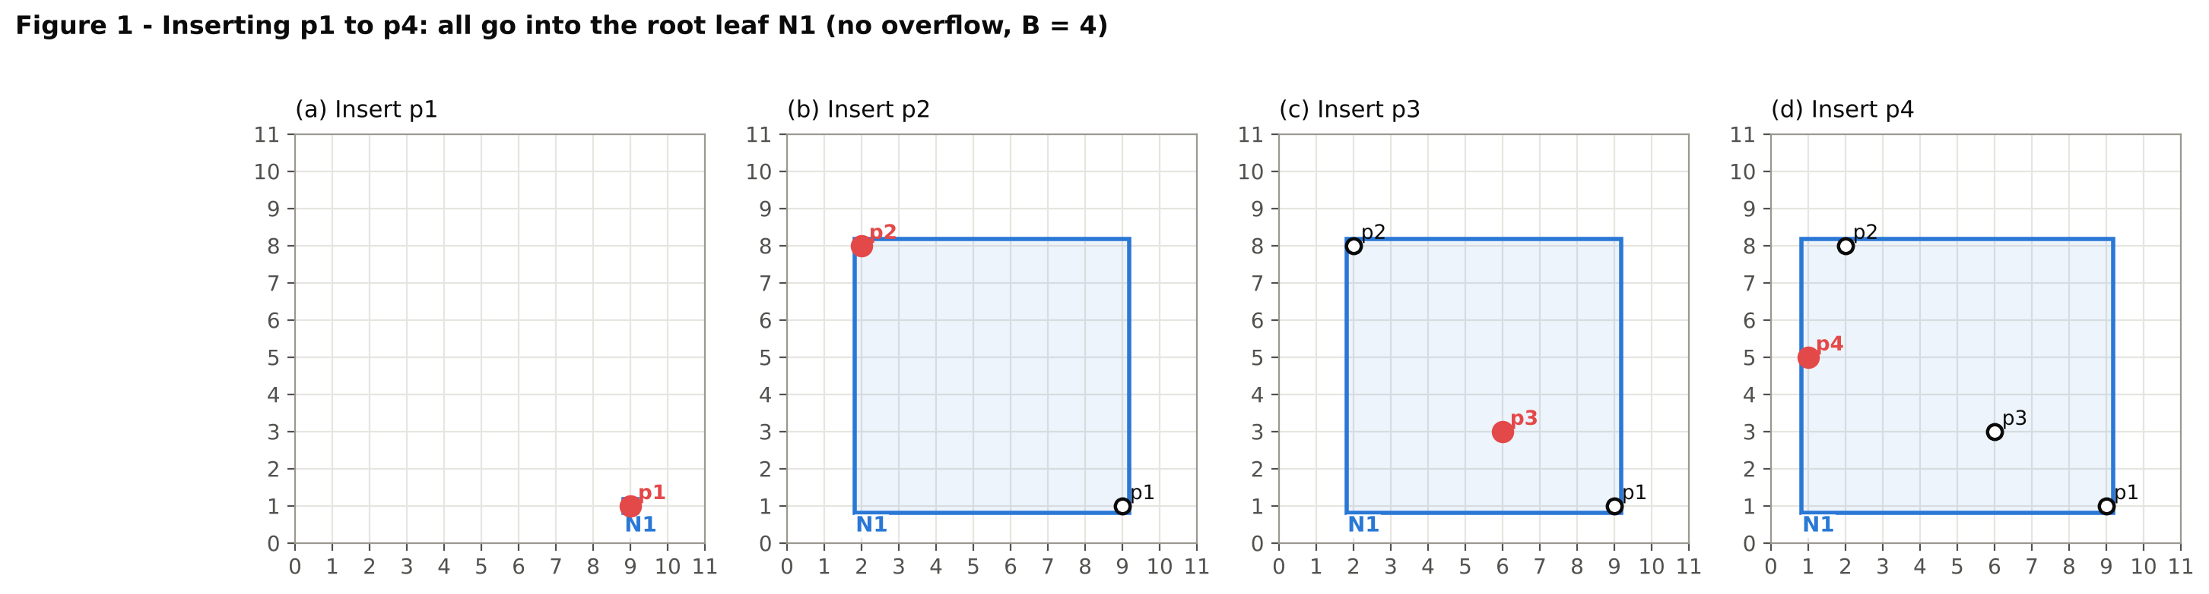
Step 2 - Insert p5(8,6): overflow and root split (Figure 2). N1 is the only node so p5 goes into it, giving 5 entries > B, so N1 must be split. Every split that was tried:
Sort axis / order | Cut | S1 (MBR, perimeter) | S2 (MBR, perimeter) | Sum
x: p4 p2 p3 p5 p1 | 2 | 3 | {p4,p2} [(1,5),(2,8)], 8 | {p3,p5,p1} [(6,1),(9,6)], 16 | 24 ← best
x | 3 | 2 | {p4,p2,p3} [(1,3),(6,8)], 20 | {p5,p1} [(8,1),(9,6)], 12 | 32
y: p1 p3 p4 p5 p2 | 2 | 3 | {p1,p3} [(6,1),(9,3)], 10 | {p4,p5,p2} [(1,5),(8,8)], 20 | 30
y | 3 | 2 | {p1,p3,p4} [(1,1),(9,5)], 24 | {p5,p2} [(2,6),(8,8)], 16 | 40

The x-axis cut after 2 points has the smallest perimeter sum (24), so N1 keeps {p4, p2} and a new leaf N2 gets {p3, p5, p1}. Because N1 was the root, a new root N3 is created with N1 and N2 as children, and the tree grows to two levels.
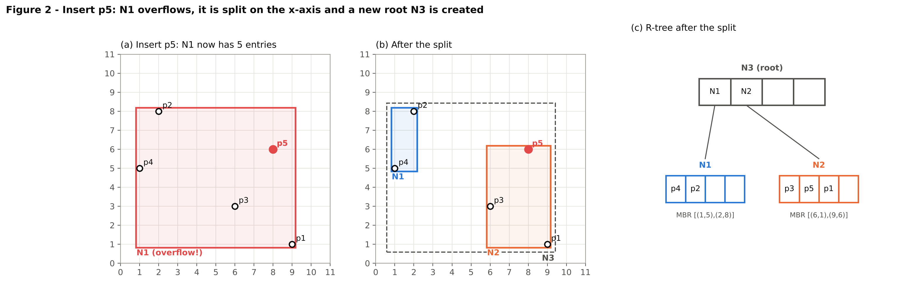
Steps 3-5 - Insert p6, p7, p8 (Figures 3-5). The root N3 is now an internal node, so choose-subtree decides the leaf:
Insert | N1 → perimeter increase | N2 → perimeter increase | Chosen | Reason
p6(3,9) | [(1,5),(2,8)] → +4 | [(6,1),(9,6)] → +12 | N1 | smaller increase
p7(10,4) | [(1,5),(3,9)] → +16 | [(6,1),(9,6)] → +2 | N2 | smaller increase
p8(3,2) | [(1,5),(3,9)] → +6 | [(6,1),(10,6)] → +6 | N1 | tie - N1 is the smaller MBR (area 8 vs 20)

None of these overflow. After p8, N1 = {p4, p2, p6, p8} and N2 = {p3, p5, p1, p7} - both leaves are full. The MBRs of N1, N2 and the root N3 are updated after each insertion.
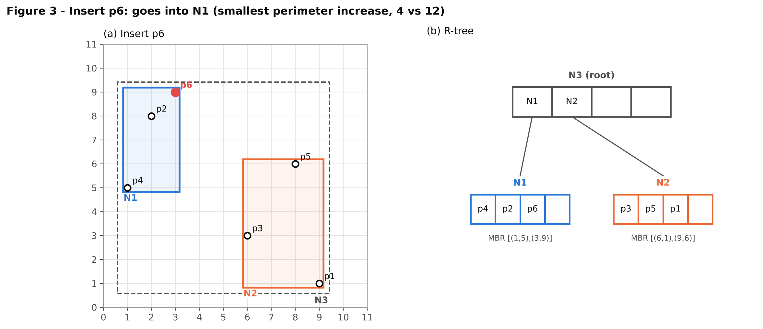
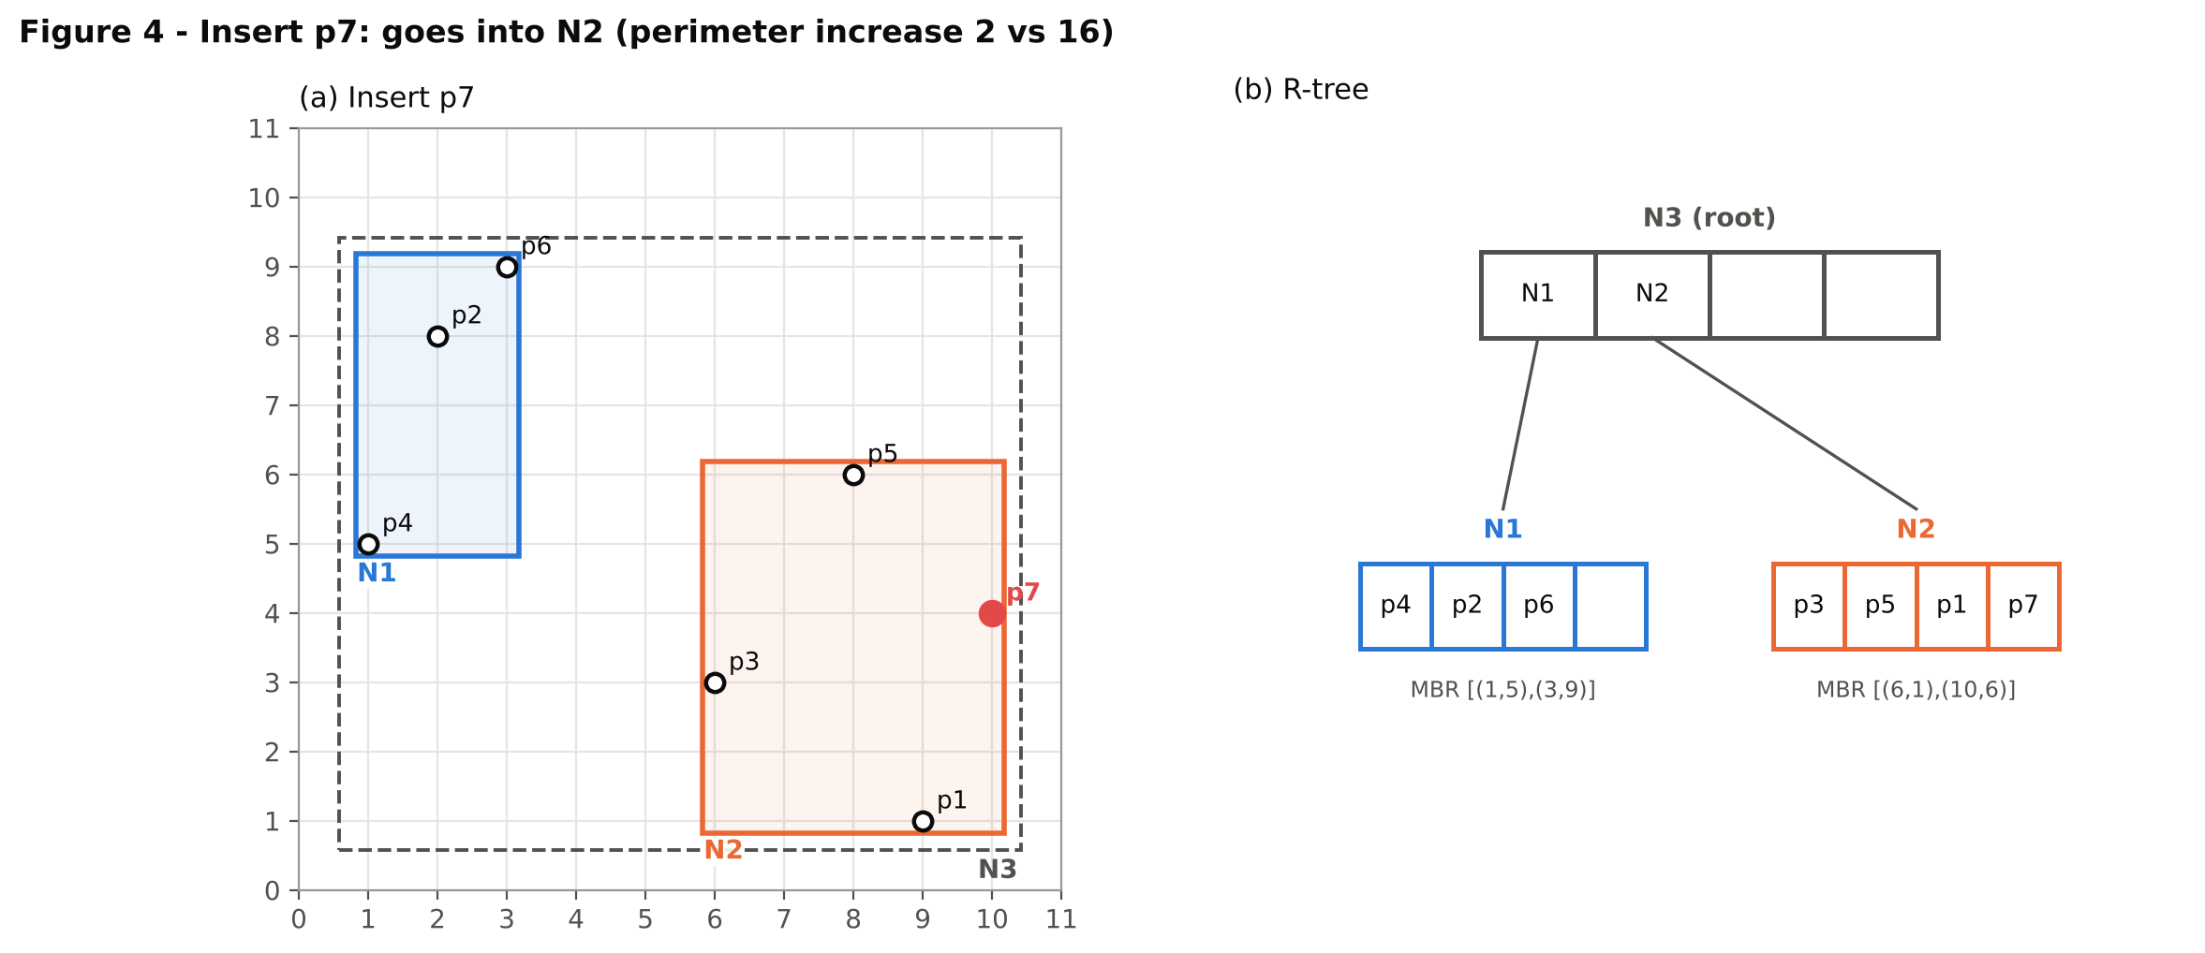
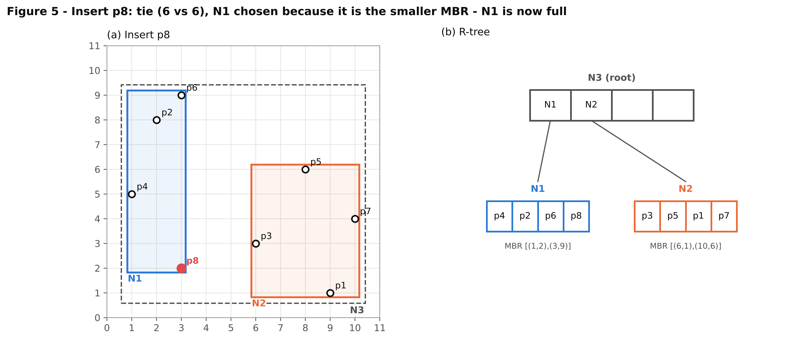
Step 6 - Insert p9(7,10): overflow of N2 (Figure 6). The perimeter increase is +10 for N1 and +8 for N2, so p9 goes into N2, which now has 5 entries and overflows. Split options:
Sort axis / order | Cut | S1 (MBR, perimeter) | S2 (MBR, perimeter) | Sum
x: p3 p9 p5 p1 p7 | 2 | 3 | {p3,p9} [(6,3),(7,10)], 16 | {p5,p1,p7} [(8,1),(10,6)], 14 | 30
x | 3 | 2 | {p3,p9,p5} [(6,3),(8,10)], 18 | {p1,p7} [(9,1),(10,4)], 8 | 26
y: p1 p3 p7 p5 p9 | 2 | 3 | {p1,p3} [(6,1),(9,3)], 10 | {p7,p5,p9} [(7,4),(10,10)], 18 | 28
y | 3 | 2 | {p1,p3,p7} [(6,1),(10,4)], 14 | {p5,p9} [(7,6),(8,10)], 10 | 24 ← best

This time the y-axis cut gives the smallest sum (24): N2 keeps the three low points {p1, p3, p7} and a new leaf N4 gets {p5, p9}. N2 is not the root, so N4 is added to the parent N3, which now has 3 children (still ≤ B, so the root does not overflow).
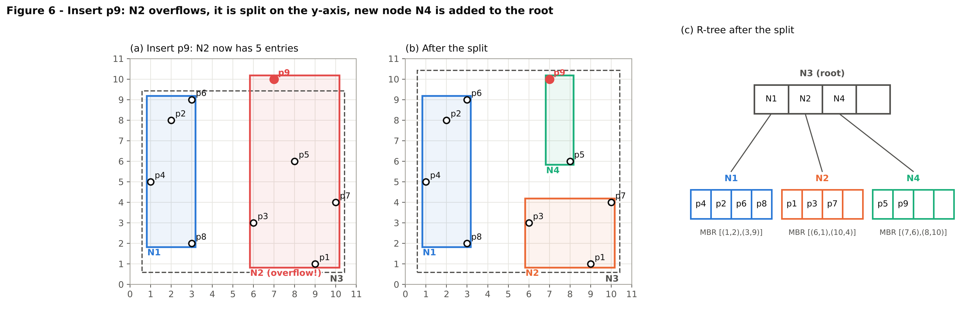
Step 7 - Insert p10(5,7): final tree (Figure 7). Perimeter increases are N1 +4, N2 +8, N4 +4. N1 and N4 tie, and N4 is chosen because it is the smaller MBR (area 4 vs 14). N4's MBR grows to [(5,6),(8,10)]. The final R-tree has root N3 with three leaves: N1 = {p4, p2, p6, p8}, N2 = {p1, p3, p7} and N4 = {p5, p9, p10}.
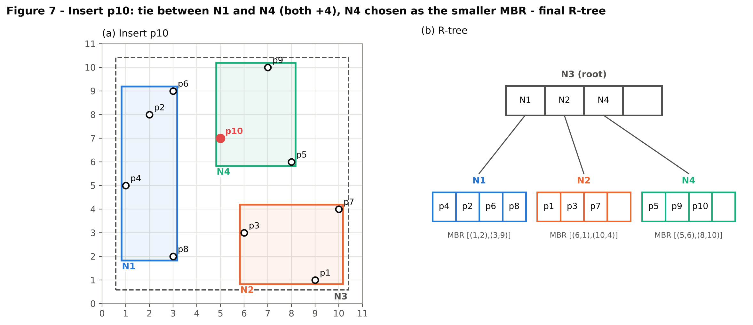

      - The Process of BF Algorithm
BF keeps a sorted list H of all entries that have been seen but not opened yet, using their mindist to q as the key. Each loop removes the entry with the smallest mindist. It stops as soon as the distance to the current best point p_best is no longer greater than the smallest mindist in H, because then nothing left in H can contain a closer point. The mindists from q(6,6) to the three leaves:
Node | MBR | mindist to q(6,6) | Why
N4 | [(5,6),(8,10)] | 0 | q is inside the MBR
N2 | [(6,1),(10,4)] | 2 | q is directly above it: 6 − 4 = 2
N1 | [(1,2),(3,9)] | 3 | q is to the right of it: 6 − 3 = 3

Step | Action | H after the step (sorted) | p_best (distance)
0 | Insert the root N3 into H | {(N3, 0)} | none (∞)
1 | Remove N3 (internal). ∞ > 0 so continue. Insert its children with their mindists. | {(N4, 0), (N2, 2), (N1, 3)} | none (∞)
2 | Remove N4 (leaf, smallest mindist 0). Distances: p5 = 2.00, p9 = 4.12, p10 = 1.41. | {(N2, 2), (N1, 3)} | p10 (1.41)
3 | Check: is 1.41 > smallest mindist in H (2)? No → stop. | {(N2, 2), (N1, 3)} - never opened | p10 (1.41) final

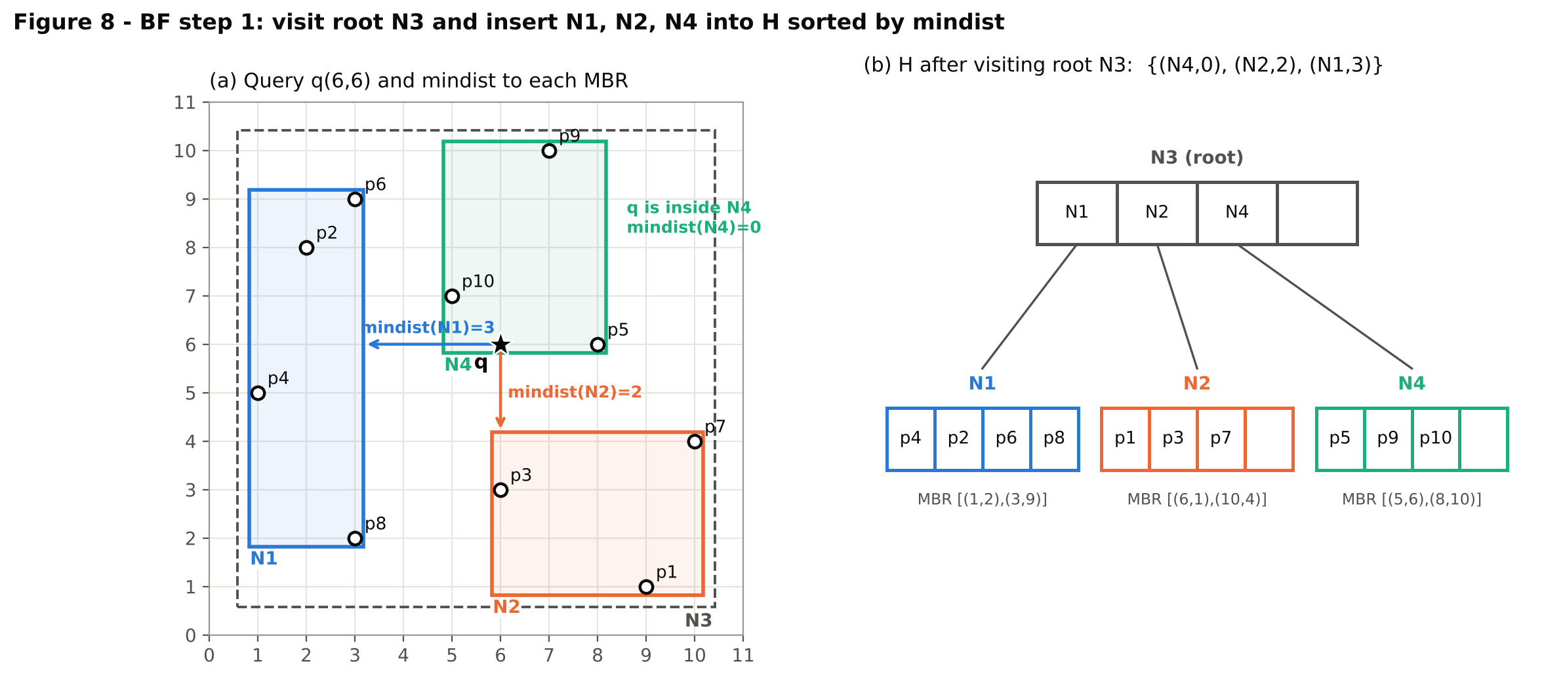
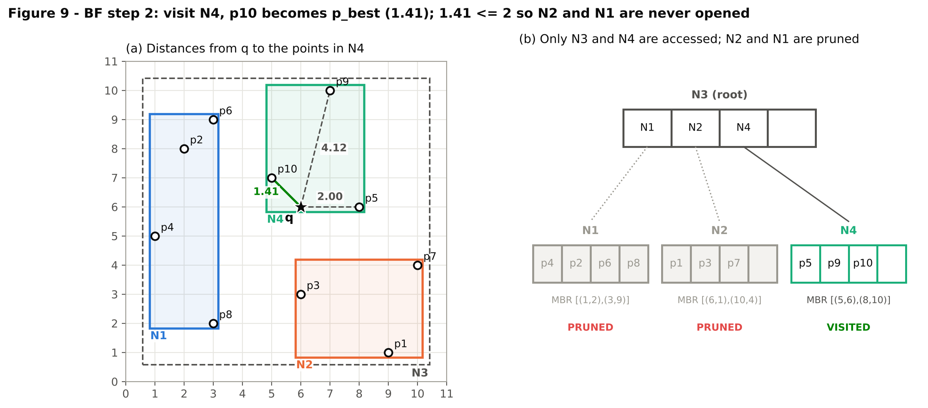
Result: the nearest neighbour of q is p10(5,7) with distance √2 ≈ 1.41. BF only accessed the root N3 and the leaf N4 and computed just 3 point distances. N2 and N1 were pruned: their mindists (2 and 3) are larger than 1.41, so no point inside them can be closer than p10. A sequential scan would need all 10 distances, which is why BF is so much faster on the full 150,000-point dataset.

      - The Process of Divide-and-Conquer
Divide. All 10 points are sorted in ascending order of y and cut into 4 subspaces of almost equal size. 10 / 4 = 2 remainder 2, so the first two subspaces get 3 points and the last two get 2:
Subspace | Points (sorted by y) | y range | Size
S1 | p1(9,1), p8(3,2), p3(6,3) | 1 - 3 | 3
S2 | p7(10,4), p4(1,5), p5(8,6) | 4 - 6 | 3
S3 | p10(5,7), p2(2,8) | 7 - 8 | 2
S4 | p6(3,9), p9(7,10) | 9 - 10 | 2

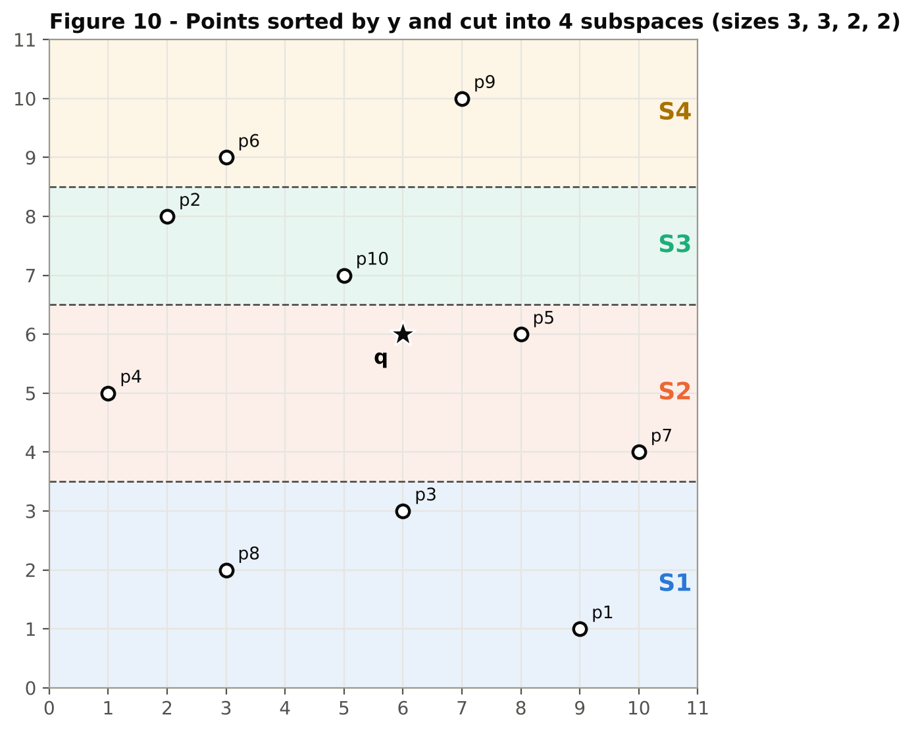
Build one R-tree per subspace. Each subspace gets its own R-tree, built with the same shared module and the same B = 4. Every subspace has at most 3 points, so no overflow happens and each tree is a single root leaf: S1 = [(3,1),(9,3)], S2 = [(1,4),(10,6)], S3 = [(2,7),(5,8)], S4 = [(3,9),(7,10)].
Conquer - BF on each tree. BF runs on each tree separately with q(6,6). Each time, H starts with the single root leaf; the leaf is removed and its points are checked, then H is empty and the search stops:
Subspace | mindist(q, root) | Distances computed | Candidate NN
S1 | 3.00 | p1 = 5.83, p8 = 5.00, p3 = 3.00 | p3 (3.00)
S2 | 0 (q inside) | p7 = 4.47, p4 = 5.10, p5 = 2.00 | p5 (2.00)
S3 | 1.41 | p10 = 1.41, p2 = 4.47 | p10 (1.41)
S4 | 3.00 | p6 = 4.24, p9 = 4.12 | p9 (4.12)

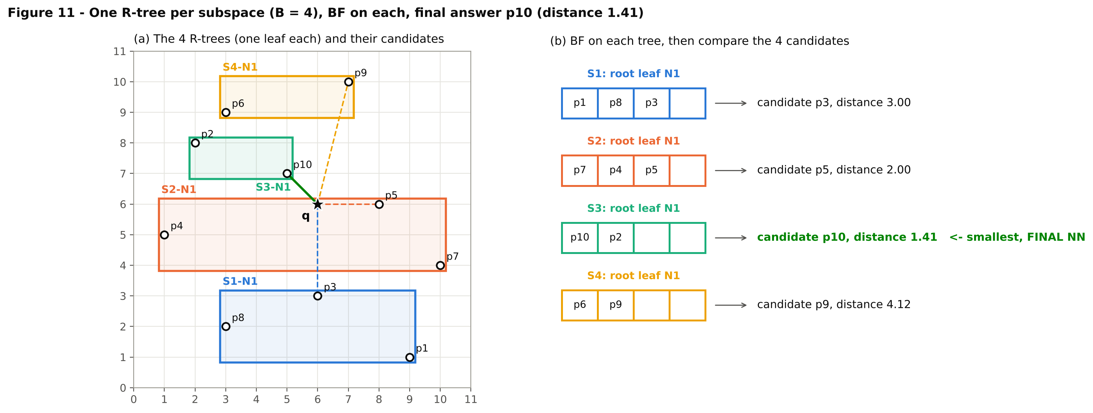
Combine. The four candidates are compared: 1.41 < 2.00 < 3.00 < 4.12, so the final nearest neighbour is p10(5,7) with distance 1.41 - the same answer as plain BF and the sequential scan.
Comparison with plain BF. On this sample, divide-and-conquer computed all 10 distances (4 leaves opened) while plain BF needed only 3 (1 leaf opened). Each subspace is searched independently, so a good candidate in one subspace (p10 in S3) cannot prune the leaves of the other subspaces. The same effect shows in the full-dataset timing, where BF + D&C (0.0136 s) is slower than BF (0.0052 s), although both are still hundreds of times faster than the sequential scan.

3.3 TASK 3:

3.3.1 Program Organization
If your assignment consists of multiple files and/or classes, please provide brief, high-level descriptions of each file/class within your program, as illustrated below.
Class/File Name | Description (detailed information)
Function Description
Function Name  (parameters) | Description (detailed information)
    - Analyzing the Working of Task 3:

3.3.2.1The Process of R-Tree Construction

      - The Process of BBS Algorithm

      - The Process of Divide-and-Conquer

